EXP NO 1: CREATE A SIMPLE CLOUD SOFTWARE APPLICATION AND PROVIDE IT AS A SERVICE USING ANY CLOUD SERVICE PROVIDER TO DEMONSTRATE SOFTWARE AS A SERVICE (SAAS).
DATE:
AIM:
To create a simple cloud software application and provide it as a service using any cloud service provider to demonstrate software as a service (saas).

PROCEDURE:
STEP1: GOTO ZOHO.COM
STEP 2: LOGIN TO THE ZOHO.COM
STEP 3: SELECT ONE APPLICATION
STEP 4: ENTER APPLICATION NAME
STEP 5: CREATED NEW APPLICATION
STEP 6: SELECT ONE FORM
STEP 7: THE SOFTWARE HAS BEEN CREATED.

IMPLEMENTATION
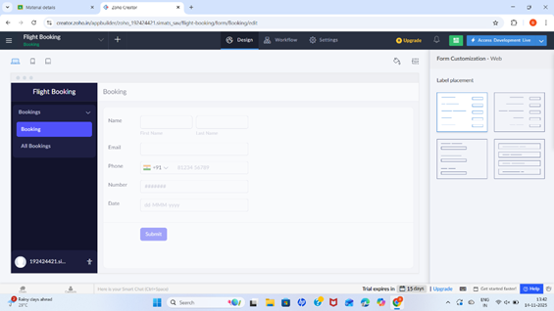
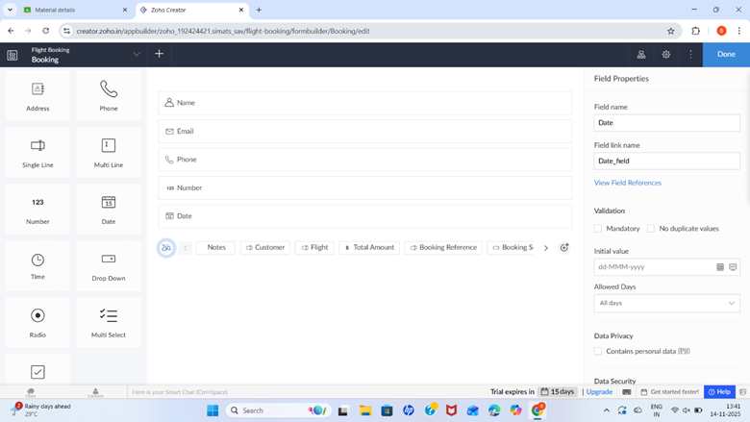
RESULT:
Successfully Created a simple cloud software application and provide it as a service using any cloud service provider to demonstrate Software as a Service (SaaS).

